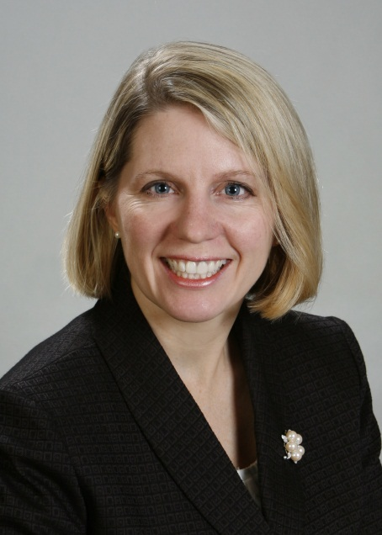
Sharon F. DiPaolo, Esquire
Siegel Jennings Co., L.P.A.
430 Freeport Road
Pittsburgh, PA 15238
(412) 486-2848
sdipaolo@siegeltax.com
www.siegeltax.com

Sharon F. DiPaolo is a partner in the property tax law firm of Siegel Jennings, Co., L.P.A. where she is a member of the Leadership Team and manages the firm’s Pennsylvania practice. Sharon concentrates her law practice exclusively in property tax law representing commercial taxpayers. She has handled thousands of assessment appeals at the administrative, trial court and appellate levels. She handles appeals for commercial property owners throughout Pennsylvania’s 67 counties, and also functions as national outside counsel for portfolio clients managing their appeals across the country. Sharon is on the planning committee for Siegel Jennings’ Annual Appraisal Summit where Siegel Jennings attorneys gather with some of the best appraisers in the county to discuss a specific appraisal topic; past summits have included hospitality valuation and senior housing valuation.
Sharon is the Western Pennsylvania representative to the American Property Tax Counsel (“APTC”), a national organization of property tax attorneys of which Siegel Jennings is a founding member. For over a decade Sharon has been a member of the APTC’s planning committee for its signature event, the Annual Client National Conference. She was the National Conference Chair for six years.
In 2021, Sharon was awarded the CRE® (Counselor of Real Estate) designation by The Counselors of Real Estate®, an international group of high-profile real estate professionals who provide expert advisory services to clients on complex real property and land-related matters. Only 1,000 professionals in all disciplines of real estate hold the CRE credential in the United States and 20 additional countries. Members of The Counselors of Real Estate, which was established in 1953, are commercial property professionals from leading real estate, financial, law, valuation, and business advisory firms, as well as real property experts in academia and government.
Sharon is a frequent speaker on real estate assessment issues. Speaking engagements include:
- Upcoming, October 11-13, 2023, National Conference Vice Chair, American Property Tax Counsel’s 29th Annual National Conference, Chicago, IL
- July 19, 2023, “Pennsylvania Assessment Law Update,” Pennsylvania Bar Institute, A Day on Real Estate, Pittsburgh, PA
- July 10, 2023, “How to Prepare for the Beaver County Reassessment – Part II,” Three Cord True Wealth Management, Beaver, PA
- May 3, 2023, “Pennsylvania Assessment Law Update”, Assessors’ Association of Pennsylvania Annual Conference, Kalahari Resorts, PA
- April 11, 2023, “How to Prepare for the Beaver County Reassessment- Part I”, Three Cord True Wealth Management, Beaver, PA
- March 17, 2023, Panel Member, “Market Value and Highest and Best Use”, American Bar Association-Institute for Professionals in Taxation Advanced Tax Seminar, New Orleans, LA
- February 2, 2023, “Grant Street Deceit: Were You Overbilled on Real Estate Taxes?”, CREW Pittsburgh-Appraisal Institute Joint Program, Pittsburgh, PA
- November 17, 2022, “Spot Assessment”, Assessors’ Association of Pennsylvania Annual Conference, Lancaster PA
- November 10, 2022, “Saga of the Allegheny County Common Level Ratio,” Allegheny County Bar Association, Real Property Section, Pittsburgh, PA
- October 19-21, 2022, National Program Committee, American Property Tax Counsel’s 28th Annual National Conference, Chicago, IL
- April 21, 2022, Panel Member, “Assessment Law & Practice in PA”, Pennsylvania Bar Institute, Webinar
- March 18, 2022, Panel Member, “Hot Bite-Size Developments – National Legal Property Tax Updates”, American Bar Association-Institute for Professionals in Taxation Advanced Tax Seminar, New Orleans, LA (virtual)
- October 20-22, 2021, Immediate Past National Conference Chair, American Property Tax Counsel’s 27th National Conference, Chicago, IL
- November 12, 2020, “PA Assessment Law Update”, Allegheny County Bar Association, Real Property Section
- October 22, 2020, “Valley Forge and its Progeny”, Pennsylvania Bar Institute
- October 21, 2020, “National Assessment Law Update”, National Conference of the American Property Tax Counsel, Organizer, Moderator and Panelist
- May 5, 2020, “Property Tax Relief and Impact of COVID 19”, Webinar for the Pennsylvania Hospitality and Lodging Association
- October 16-18, 2019, National Conference Chair, American Property Tax Counsel’s 25th Annual National Conference, Chicago, IL
- November 6-9, 2018, “Mock Trial”, National Conference of the Institute for Professionals in Taxation, Orlando, FL
- November 6-9, 2018, Facilitator of the Advanced Property Tax Academy Session, National Conference of the Institute for Professionals in Taxation, Orlando, FL
- October 24-26, 2018, Chair, American Property Tax Counsel’s 24th national conference in Scottsdale, AZ
- April 25, 2018, Assessors’ Association of Pennsylvania Annual Conference, “Mock Assessment Trial,” Valley Forge, PA
- December 6, 2017, Assessors’ Association of Pennsylvania, Southeastern Chapter, “Preparing for Trial Testimony”, Bucks County, PA
- October 24, 2017 “Pennsylvania Legal Update”, National Property Taxpayers Association, Chicago, Illinois;
- October 21-22, 2017, National Conference Vice Chair, American Property Tax Counsel’s 23rd Annual Seminar, Chicago, IL
- August 18, 2017, Assessors’ Association of PA, Northwestern Chapter, “How to Testify”, Clarion, PA
- May 18, 2017, Institute for Professionals in Taxation, “Hot Topics in PA Real Estate Assessment”, Pittsburgh, PA
- April 27, 2017 Counselors of Real Estate, Villanova University, “Update on Assessment Practices and Court Decisions”, Villanova, PA
- April 24, 2017 Allegheny County Bar Association, “Property Assessment Law Update”
- November 14, 2016 National Conference of the Institute for Professionals in Taxation, “When the Going Gets Tough, Assessment Attorneys Get Tougher”, Tucson, AZ
- October 20-22, 2016, National Conference Chair, American Property Tax Counsel’s 22nd Annual Seminar, Atlanta, GA
- November 19, 2015, Southpointe Chamber of Commerce, “Washington County’s Reassessment”, Southpointe, PA
- November 2, 2015, National Conference of the Institute for Professionals in Taxation, “Assessment War College - The Industrial Battlefield,” Austin, TX
- October 23-24, 2015 National Conference Chair, American Property Tax Counsel’s 21st Annual Seminar, Atlanta, GA
- May 2015, Assessors’ Association of Pennsylvania, Mock Trial, Seven Springs, PA
- August 2014, National Conference of the Appraisal Institute “Preparing the Appraiser for Trial Testimony: Training, Tips and Techniques from the Front Lines,” Austin, TX
- November 2014 National Conference of the Institute for Professionals in Taxation, “Litigation Management in Assessment Appeals,” Ft. Lauderdale, FL
Sharon has been published in the Assessors’ Association of Pennsylvania Journal, National Real Estate Investor Online, REBusiness Online, Commercial Real Estate Executive and IPT Insider. She has been quoted on property tax issues in Bloomberg BNA Report, The Pittsburgh Business Times, The Pittsburgh Post Gazette, The Pittsburgh Tribune Review and The Pew Charitable Trusts Philadelphia Research Initiative.
With over 25 years in the practice of law, Sharon spent several years in a commercial litigation practice before concentrating her practice exclusively on property tax litigation beginning 2001. Prior to joining Siegel Jennings, Sharon was a partner with Reed Smith LLP and with Pepper Hamilton LLP.
Sharon is a 1988 magna cum laude graduate of Duquesne University honors program and a 1994 cum laude graduate of the University of Pittsburgh School of Law where she was Managing Editor of the University’s Journal of Law and Commerce. Sharon is a Member of the Real Property Section of the Allegheny County Bar Association and is an active member of the Institute for Professionals in Taxation. Sharon is also active in Commercial Real Estate Women (“CREW”) Pittsburgh. She is past Chair of the Board of Trustees of Holy Family Learning and past Director of the Board of The Midwife Center, Pittsburgh, PA.

