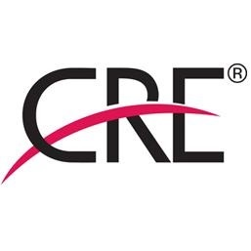

The Counselors of Real Estate Foundation

140 S Dearborn Street, Suite 1500A, Chicago, IL 60603  312-329-8427  312-329-8881 fax  www.cre.org 

APPLICATION FOR FUNDING

I. EXECUTIVE SUMMARY

Title of Project:
$ Amount Requested:
Submitted by (name, company):
Address:
Phone:
Fax:
Email:

Concept of Project and Need It Is Expected to Fill:

II. OVERVIEW
(Background of proposed project and/or entity making request, and relationship of project to education and real property; elaboration on whether additional funding from other sources has been secured (include name of funding source and amount pledged) or will be pursued.

Description of Project:

Purpose:

Financial Partners and Contributors (other than the CRE Foundation):

Role of Key Individuals who will participate in the project (particularly CRE volunteers whose involvement in projects funded by the CRE Foundation is encouraged):

III. MILESTONE DATES AND TIMETABLE
(What will be accomplished when)

IV. BUDGET
(Preliminary budget of expected costs and/or revenues to be attached on separate sheet.)

V. EXPECTED IMPACT
(What outcome is expected and how will the project’s success be evaluated? Why does this project matter and who does it benefit?)

VI. RELEVANCE
(Relationship to real estate; description of project’s educational component; and statement explaining how the project compliments the character and core values of The Counselors of Real Estate)

VII. STRATEGY FOR EXTERNAL PROMOTION/EXPOSURE OF PROJECT AND RECOGNITION OF CRE FOUNDATION’S ROLE THEREIN

VIII. STRATEGY FOR SUSTAINABILITY
(Include a statement, if applicable, on whether the program is ongoing, and, if so, how it will be funded in the future?)

Note: Questions on whether or not a proposed project meets Foundation Guidelines may be directed to Mary Walker Fleischmann (mfleischmann@cre.org; 312-329-8428).

Submit Application Now.

